
My Target: ____ / or ______ % Complete on the day of the test
  (Circle when your test is handed back)

Year 9 Humanities and Social Science - Geography – 2017 – Semester Two

Name: ____________________________ Class group: ____________________
Total marks | % | Weight
53 |  | %

Learning Intention: Research Inquiry into Food.

Success Criteria: A completed booklet on one of the topics below.

DUE DATE: ___________________________________________

Teacher signature: ______________________________________

Student signature: _______________________________________

Parent signature: ________________________________________

Task 1: Inquiry Task (%) Summary of task: Research one of the topics below. You must refer to the rubric and address each of the criteria. Pay particular attention to correctly listing bibliography on a separate page. You will have time in class to research and will be expected to work on this for homework.


TOPICS

Topic 1: Chocolate: from the ground to the mouth.
Key research areas:
- World production
- World consumption
- Chocolate industry
- Issues with chocolate production and consumption


Topic 2: Food Security
Key research areas:
- Food availability
- Food accessibility
- Food utilization
- Food stability

Topic 3: Globosity
Key research areas:
- High rates of overweight/obesity
- Supersized world
- Interconnections – food/income
- Fast food industry

PART A: Inquiry Booklet
Brainstorm
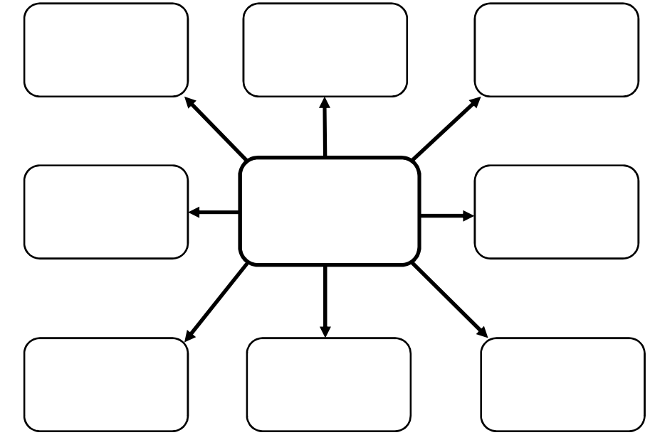
Use the box provided below to brainstorm you chosen topic.

Complete the KWL chart below
K | W | L
What do you already know about the topic? | What do you want to know about the topic? | What have you learned about the topic?
Topic: _______________________________________________________

Inquiry research area:

Key points from information sources and reference details (5 marks)

Topic: ________________________________________

Inquiry research area:

Key points from information sources and reference details (5 marks)
Topic: ________________________________________

Inquiry research area:

Key points from information sources and reference details (5 marks)

Topic: ________________________________________

Inquiry research area:

Key points from information sources and reference details (5 marks)

Complete the PMI chart below TASK
P – Plus | M - Minus | I - Interesting
Positives (Pluses)  about the task | Negatives (Minuses)  about the task | Interesting parts  of the task

TOPIC
P – Plus | M - Minus | I - Interesting
Positives (Pluses)  about the topic | Negatives (Minuses)  about the topic | Interesting parts  of the topic
Assessment 1: Year 9 –Geography Inquiry Task – Checklist/Marking Key
Assessment Task
Inquiry Booklet | Marks Available | Your Marks
Description
KLW Chart – Completed KWL Chart  Includes 5-6 key points under each heading or has used detail for at least two columns, such as ‘Want to Know and Learnt’. Uses a brief explanation for each point. | 5-6
Includes 3-4 key points under each heading or has used some detail for at least two columns, such as ‘Want to Know and Learnt’. Uses basic detail. | 3-4
Includes 1-2 key point under each heading. No detail provided. | 1-2
Subtotal | 6
Description
Brainstorm – Completed Brainstorm
Includes 7-8 brainstorm points inside each bubble. | 7-8
Includes 5-6 brainstorm points inside each bubble. | 5-6
Includes 3-4 brainstorm points inside each bubble. | 3-4
Includes 1-2 brainstorm points inside each bubble. | 1-2
Subtotal | 8
Description
Inquiry Research Area 1
Outlines five key points of information relevant to the topic | 5
Outlines four key points of information relevant to the topic | 4
Outlines three key points of information relevant to the topic | 3
Outlines two key points of information relevant to the topic | 2
Outlines one key point of information relevant to the topic | 1
Subtotal | 5
Inquiry Research Area 2
Outlines five key points of information relevant to the topic | 5
Outlines four key points of information relevant to the topic | 4
Outlines three key points of information relevant to the topic | 3
Outlines two key points of information relevant to the topic | 2
Outlines one key point of information relevant to the topic | 1
Subtotal | 5
Inquiry Research Area 3
Outlines five key points of information relevant to the topic | 5
Outlines four key points of information relevant to the topic | 4
Outlines three key points of information relevant to the topic | 3
Outlines two key points of information relevant to the topic | 2
Outlines one key point of information relevant to the topic | 1
Subtotal | 5
Inquiry Research Area 4
Outlines five key points of information relevant to the topic | 5
Outlines four key points of information relevant to the topic | 4
Outlines three key points of information relevant to the topic | 3
Outlines two key points of information relevant to the topic | 2
Outlines one key point of information relevant to the topic | 1
Subtotal | 5
Description
Organisation of information and/or data
Organises information and/or data into clear categories using appropriate subheadings | 5-6
Organises information and/or data into some categories using subheadings | 3-4
Organises information and/or data in a limited fashion | 1-2
Subtotal | 6
Description
Bibliography
Follows correct format according to referencing technique approved by the school | 3-4
Lists sources used | 1-2
Subtotal | 4
Description – Evaluating and Reflecting
PMI Chart – Completed PMI Chart (Task and Topic)  Includes 5-6 key points in total for the task (2 under each heading).  Includes 3 points for the topic (1 under each heading)  Uses a brief explanation for each point. | 5-9
Includes 3-4 key points under each heading. Uses basic detail. | 3-4
Includes 1-2 key point under each heading. No detail provided. | 1-2
Subtotal | 9

Comment:

To improve:

